IIT-JEE-Physics-Screening-2003
Screening _______________________________________________________________
1. A metallic shell has a point charge 'q' kept inside its cavity. Which one of the following diagrams correctly represents the electric lines of forces?
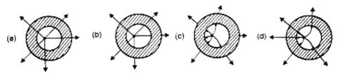
2. What is the maximum value of the force F such that the block shown in the arrangement, does not move?
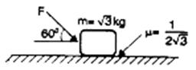
(a) 20 N
(b) 10 N
(c) 12 N
(d) 15 N
3. Consider a body, shown in figure, consisting of two identical balls, each of mass M connected by a light rigid rod. If an impulse J = MV is imparted to the body at one of its ends, what would be its angular velocity?
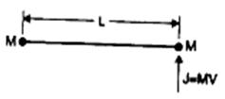
(a) V/L
(b) 2V/L
(c) V/3L
(d) V/4L
4. If W₁, W₂ and W₃ represent the work done in moving a particle from A to B along three different paths 1, 2 and 3 respectively (as shown) in the gravitational fields of a point mass m. Find the correct relation between W₁, W₂ and W₃.
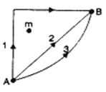
(a) W₁ > W₂ > W₃
(b) W₁ = W₂ = W₃
(c) W₁ < W₂ < W₃
(d) W₂ > W₁ > W₃
5. A cube has a side of length 1.2 × 10⁻² m. Calculate its volume.
(a) 1.7 × 10⁻⁶ m³
(b) 1.73 × 10⁻⁶ m³
(c) 1.70 × 10⁻⁶ m³
(d) 1.732 × 10⁻⁶ m³
3λ/2 λ/4d λ/d 4λ/d
6. The graph, shown in the adjacent diagram, represents the variation of temperature (T) of two bodies, x and y having some surface area, with time (t) due to the emission of radiation. Find the correct relation between the emissivity and absorptivity power of the two bodies.
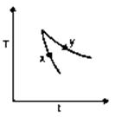
(a) E_{x} > E_{y} and a_{x} < a_{y}
(b) E_{x} < E_{y} and a_{x} > a_{y}
(c) E_{x} > E_{y} and a_{x} > a_{y}
(d) E_{x} < E_{y} and a_{x} < a_{y}
7. The adjacent graph shows the extension (Dl) of a wire of length I m suspended from the top of a roof at one end and with a load W connected to the other end. If the cross-sectional area of the wire is 10⁻⁶ m², calculate the Young's modulus of the materials of the wire.
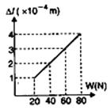
(a) 2 × 10¹¹ N/m²
(b) 2 × 10⁻¹¹ N/m²
(c) 3 × 10¹² N/m²
(d) 2 × 10¹³ N/m²
8. In the adjacent diagram, CP represents a wavefront and AO and BP, the corresponding two rays. Find the condition on q for constructive interference at P between the ray BP, and reflected ray OP.
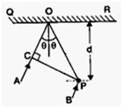
(a) cos θ = 3λ/2
(b) cos θ = λ/4d
(c) sec θ - cos θ = λ/d
(d) sec θ - cos θ = 4λ/d
9. Two rods, one of aluminum and other made of steel, having initial length l₁, and l₂ are connected together to form a single rod of length l₁ + l₂. The coefficients of linear expansion for aluminium and steel are a_{a} and a_{s} respectively. If the length of each rod increases by the same amount when their temperature. If the length of each rod increases by the same amount when their temperature are raised by t⁰C, then find the ration l₁ / (l₁ + l₂).
(a) α_{a} / α_{s}
(b) α_{s} / α_{a}
(c) α_{s} / (αa + α_{s})
(d) α_{a} / (αa + α_{s)}
10. The size of the image of an object, which is at infinity, as formed by a convex lens of focal length 30 cm. If a concave lens of focal length 20 cm is placed between the convex lens and the image at a distance of 26 cm from the convex lens, calculate the new size of the image.
(a) 1.25 cm
(b) 2.5 cm
(c) 1.05 cm
(d) 2 cm
11. A ray of light is incident at the glass-water interface at an angle I, it emerges finally parallel to the surface of water, then the value of mg would be:
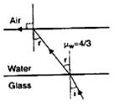
(a) (4/3) sin I
(b) 1/sin i
(c) 4/3
(d) 1
12. The electric potential between a proton and an electron is given by V = V₀ In r/r₀, where r₀ is a constant. Assuming Bohr's model to be applicable, write variation of r_{n} with n, n being the principal quantum number?
(a) r_{n} ∞ n
(b) r_{n} ∞ 1/n
(c) r_{n} ∞ n²
(d) r_{n} ∞ 1/n²
13. If the atom ₁₀₀Fm²⁵⁷ follows the Bohr model and the radius of ₁₀₀Fm²⁵⁷ is n times the Bohr radius, then find n.
(a) 100
(b) 200
(c) 4
(d) ¼
14. When an AC source of emd e = E₀ sin (100 t) is connected across a circuit, the phase difference between emf e and the current I in the circuit is observed to be Π/4, as shown in the diagram. If the circuit consists possibly only of R-C or R-L or L-C in series , find the relationship between the two elements.
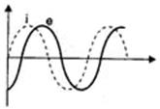
(a) R = 1kW, C = 10 mF
(b) R = 1kW, C = 1mF
(c) R = 1kW, L = 10H
(d) R = 1kW, L = 1H
15. For a positively charged particle moving in a x-y plane initially along the x-axis, there is a sudden change in its path due to the presence of electric and/or magnetic fields beyond P. The curved path is shown in the x-y plane and is found to be non-circular.
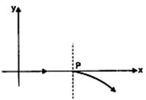
Which one of the following combinations is possible.
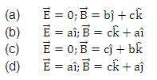
16. Express which of the following set up can be used to verify ohm's law?
(a)
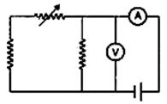
(b)
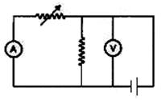
(c)
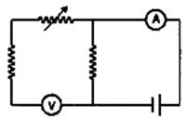
(d)
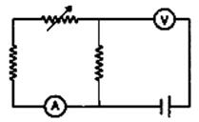
17. The PT diagram for an ideal gas is shown in the figure, where AC is an adiabatic process, the find the corresponding PV diagram:
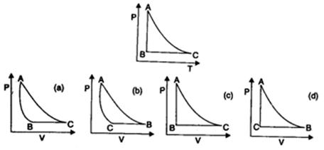
18. A police car moving at 22 m/s, chases a motorcyclist. The police man sounds his horn at 176 Hz, while both of them move towards a stationary siren of frequency 165 Hz. Calculate the speed of the motorcycle, if it is given that he does not observe any beats.
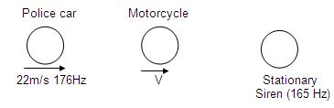
(a) 33 m/s
(b) 22 m/s
(c) zero
(d) 11 m/s
19. The uranium nucleus how does its mass vary with volume ?
(a) m ∝ V
(b) m ∝ 1/V
(c) m ∝ √V
(d) m ∝ V²
20. For a particle executing SHM the displacement x is given by x = A cos wt. Identify the graph which represents the variation of potential energy (PE) as a function of time t and displacement x.
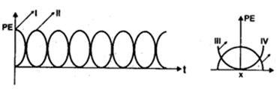
(a) I, III
(b) II, IV
(c) II, III
(d) I, IV
21. In the experiment for the determination of the speed of sond in air using the resonance column method, the length of the air column that resonates in the fundamental mode, with a tuning fork is 0.1 m. When this length is changed 0.35 m, the same tuning fork resonates with the first overtone. Calculate the end correction.
(a) 0.012 m
(b) 0.025 m
(c) 0.05 m
(d) 0.024 m
22. A particle undergoes uniform circular motion. About which point on the plane of the circle, will the angular momentum of the particle remain conserved?
(a) centre of the circle
(b) on the circumference of the circle
(c) inside the circle
(d) outside the circle
23. A conducting loop carrying a current I is placed in a uniform magnetic field pointing into the plane of the paper as shown. The loop will have a tendency to:
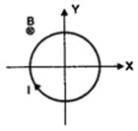
(a) contract
(b) expand
(c) move towards +ve x-axis
(d) move towards -ve x-axis
24. A current carrying loop is placed in a uniform magnetic field in four different orientation, I, II, III and IV, arrange them in the decreasing order of potential energy :
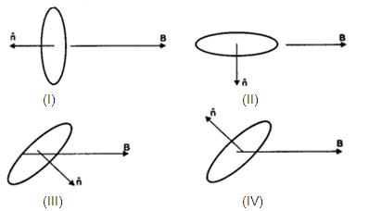
(a) I > III > II > IV
(b) I > II > III > IV
(c) I > IV > II > III
(d) III > IV > I > II
25. 2 kg of ice at 20ºC is mixed with 5 kg of water at 20ºc in an insulating vessel having a negligible heat capacity. Calculate the final mass of water remaining in the container. It is given that the specific heats of water and ice are 1 kcal/kg/ºC and 0.5kcal/kg/ºC while the latent heat of fusion of ice is 80 kcal/kg :
(a) 7 kg
(b) 6 kg
(c) 4 kg
(d) 2 kg
26. In the shown arrangement of the experiment of the meter bridge if AC corresponding to null deflection of galvanometer is x, what would be its value if the radius of the wire AB is doubled?
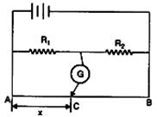
(a) x
(b) x/4
(c) 4x
(d) 2x
27. The three resistance of equal value are arranged in the different combinations shown below. Arrange them in increasing order of power dissipation :
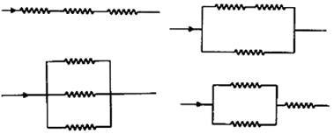
(a) III < II < IV < I
(b) II < III < IV < I
(c) I < IV < III < II
(d) I < III < II < IV
28. A nucleus with mass number 220 initially at rest emits an a-particle. If the Q value of the reaction is 5.5 MeV, calculate the kinetic energy of the a-particle :
(a) 4.4 MeV
(b) 5.4 MeV
(c) 5.6 MeV
(d) 6.5 MeV

